REVISION with C / C++

1. *Write a program to interchange the rows of the matrix and display the elements column-wise.*

*Sample input : 1 2 3*

*4 5 6*

*7 8 9*

*Rows interchanged: 3 2 1*

*6 5 4*

*9 8 7*

*Output Col-wise : 3 6 9*

*2 5 8*

*1 4 7*

1. *Write a program to add set of numbers and find display its total and average through a single function. (Use variable arguments).*
2. *Write a program to accept a sentence and store the same in the integer matrix, where each character is stored in its ascii form and each row represents a word. Display the sentence in this encrypted form. Demonstrate the memory efficient 2-D array in this example.*

***Input : “my name is not agentx”***

***Encoded matrix form output :***

***109 121***

***110 97 109 101***

***105 115***

***110 111 116***

***97 103 101 110 116 120***

***Challenge Programs:***

1. ***Design and develop a C-program to simulate ‘Snakes & Ladders’ game. (Use Random class to generate a random number between 0 and Max for the dice value)***

***Explanation:***

***It is a multi-player game. Initially simulate the game for 2 players only. Players have to throw dice turn-by turn. Each time a dice is thrown by a player, its face value is used to count the moves on the board. The board has 100 boxes starting from 1. A sample image is shown:***

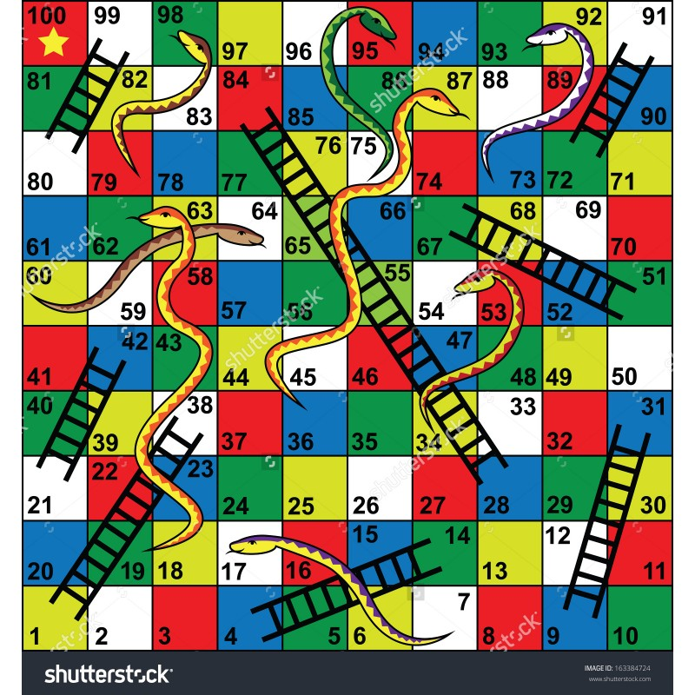

***Rules of the game:***

1. *If any player reaches the box having the base of the ladder, the player climbs-up the ladder to the new position.*
2. *If any player reaches the box having a head of the snake, the player has to climb-down till the tail of the snake.*
3. *If the player has reached a position near the destination and the dice value is more than the required, the player loses one turn, and cannot move from the current position. The player has to wait for the next chance.*
4. *Any player reaches the 100th box, the final destination, is declared winner. (The game ends in case of two players and continues in case of multiple players until one player is left-out).*